Directions to log into the Portal.
- Go to Seminole County Public Schools website to access the portal.
https://www.scps.k12.fl.us/portal/index.stml
- Click on the picture of the Portal.
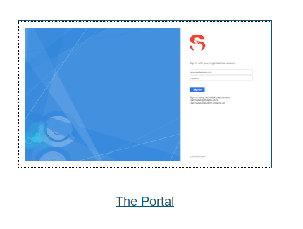
- Enter your username and password.

Directions for accessing the Math and Science books online through the Portal.
Science Book
- Log in to the Portal using your username and password.
https://www.scps.k12.fl.us/portal/index.stml

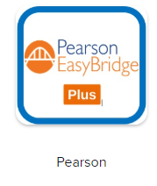
- Under Class Tools click on Pearson Easybridge Plus icon.

- Click on Person Elevate Science Florida Edition Grade 3.
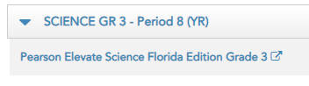
The following only have to be done the first time the student goes on to Person Elevate.
Follow along and choose the language, profile icon, and background image you would like to see every time you log in to Pearson Elevate. After you have made your choices click on “Let’s go”.
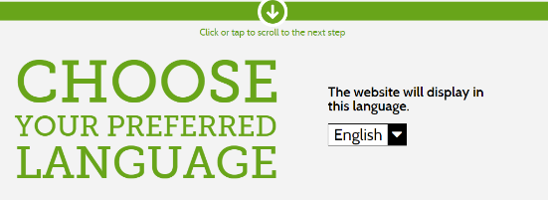
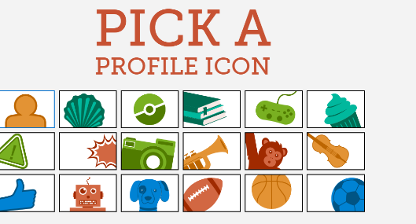
- Click on Pearson Elevate green box.
- Click on topic we are on in class. Our weebly website will tell you the topic we are working on in class.
https://glumandhaefner.weebly.com/

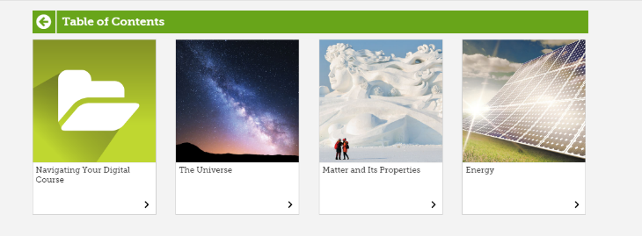
- Click on the lesson you would like to work on
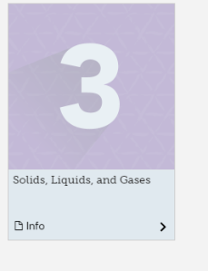
- Click on etext for the book or click on video for a short video on the topic.
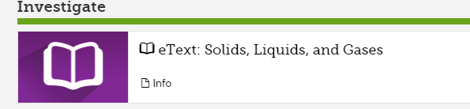
If you have anydifficulty, please let me know and I will do my best to help you.

Math Book online through the Portal.
- Log in to the Portal using your username and password.
https://www.scps.k12.fl.us/portal/index.stml

- Scroll down the section for “Class Tools”

- Click on Think Central icon.
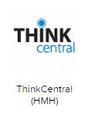

- Click on My Library.
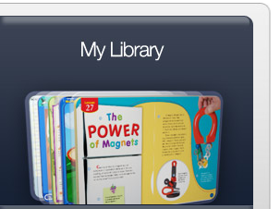
- Choose Standards Practice book if you need another paper for homework or Student Edition to see the textbook and lessons we use in class. 